**Algebra 3-4   
1st Semester Final**

**Name: _____________________ Block: _________  
 Print**

**Name: _____________________  
 Signature**

**Test Sections Score**

**Chapter 1 Expressions, Equations and Inequalities ______  
  
Chapter 2 Functions, Equations and Graphs ______  
  
Chapter 4 Quadratic Functions and Equations ______  
  
Chapter 5 Polynomial and Polynomial Functions ______**

**1st Semester Final ______**

**Chapter 1**

Evaluate Using Order of Operations. [L2]

1.) $10+7*4-3^{2}$ 1._________________

2.) $\left(5+4*2\right)-(-10+6*4)$ 2._________________  
  
  
Solve for the indicated variable. [L2]

$3.) Solve for C: F=\frac{9}{5}C+32$ 3._________________  
  
  
4.) $Solve for r: I=Prt$ 4._________________   
  
  
5.) $Solve for h: A=\frac{h}{2}(b_{1}+b_{2})$ 5._________________  
  
  
Solve the Expression for x. [L2]

6.) $4\left(2x-3\right)-6x=10$ 6._________________

Solve the Expression for x. [L3]

7.) $5x^{2}-2=178$ 7._________________

Solve the equation. Check for extraneous solutions. [L3]

8.) $3\left|x+5\right|=30$ 8._________________

Write an Equation and Solve. [L4]

9. Beth has $500 in her savings account and makes $25 per day babysitting. 9._________________  
Write an equation to represent this situation.   
How many days until she will have $2000 saved?

**Chapter 2**

Identify the domain and range. Then tell whether the relation is a function.[L2]   
  
1.) {(3, 2), (-2, 5), (1, 0), (-4, 6), (1, -1)} 1. Domain: __________   
 Range __________   
   
 Function? _________   
Decided whether the given function is linear, then evaluate it for the given value of x. [L2]

2.)  2._________________

Write the Equation in Slope-Intercept Form. [L2]

3.) -3x+2y=7 3._________________

Find the slope of the line through the given points. Then write the equation for the line. [L3]

4.) (6, 8) and (4,2 ) 4._________________

Graph the following equations. [L3]

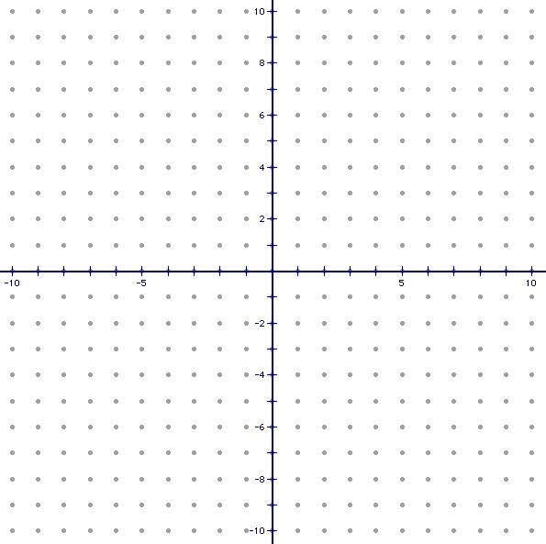5.) 2y +3x = 6 5.

Choose to answer one of the following. [L4]

6.) *Describe a real life situation that would model an event with positive correlation and write its equation.  
 -or-  
 *Write an absolute value equation with a vertex in the 3rd quadrant that reflects about the x-axis.

**Chapter 4**

Write the following in Standard Form. [L2]

$1.) y=\left(x+4\right)(x-7)$ 1. $2.) y=\frac{1}{2}\left(x+2\right)(x+8)$_________________  
  
  
 2._________________

Graph. [L2] Graph. [L3]





$3.) f\left(x\right)=-2({x-3)}^{2}+4$ $4.) f\left(x\right)=x^{2}+4x+1$

Factor the expression completely. [L2]

5.) m2 + 12m + 20 5._________________

Solve the Equations Using Any Method. [L3]

6.) x2 – 8x = -15 6._________________

Solve the following. [L4]  
7.) Campers at an aerospace camp launch rockets while attending the camp. 7._________________  
The path of the rocket is modeled by the equation $h\left(x\right)=-16t^{2}+150t+1$  
where t is the time in seconds and h is the distance from the ground (height).   
Find the maximum height of the rocket.   
After how many seconds does it reach this height?

**Chapter 5**Describe the Polynomial

$1.) f\left(x\right)=x^{5}-3x^{4}+x^{3}+x^{2}+4$ Degree: _____ **[L2]**  
Leading Coefficient: _____ **[L2]**  
Total Number of Solutions: _____ **[L2]**  
Y-Intercept: _____ **[L2]**  
List of Possible Rational Solutions: ____________________ **[L2]**  
Right End Behavior: ________ **[L2]**  
Left End Behavior: ________ **[L2]**Find all zeros (Show your work). __________ **[L3]**

Write in standard form a polynomial function with leading coefficient of 1 with zeros [L2]

2.) $2, -1, -3i$. 2.________________

Find the zeros of the following function. Multiplicities? [L3] 3. $3.) f\left(x\right)=x^{4}+5x^{3}+6x^{2}$_________________   
?

Solve the following. [L4]  
4.) The volume in cubic inches of a box can be expressed as the product of three dimensions.  
*𝑉 $\left(x\right)=x^{3}-16x^{2}+79x-???$* The length is $x-8$ (and you know it is a factor!). Find the missing constant in $V(x).$ Then find the other dimensions of the box. Assume that the width is greater than the height.

4._________________